Curriculum Vitae (CV)

Title | Miss | First Name | Bineet Kaur | Last Name |  | Chandok | Photograph
Designation |  | Assistant Professor |  |  |  |  | 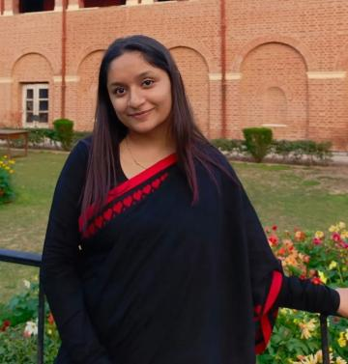
Department |  | Department of English
Address
(Campus)
Phone Number(Campus)
Fax
Email |  | bineet@spm.du.ac.in
Education |  | Ph.D. in English (Pursuing)
Subject |  | Institution |  |  | Details
English |  | Department of English, University of Delhi |  |  | Ph.D., (pursuing).
English |  | Ramjas College, University of Delhi |  |  | M.A., 2021-23
English |  | Mata Sundri College, University of Delhi |  |  | B.A. (Hons) in English, 2018-2021.
Research Interests/ Specialization
Shakespeare Studies
Trauma Studies

Teaching Experience
Taught at P.G.D.A.V. College, University of Delhi on guest basis. Oct-Dec, 2023.
Teaching at Shyama Prasad Mukherji College since January, 2024 .
Research Papers in Journals:
Epidemic: Human Relationships Mutate like Virus - Bineet Kaur Chandok - IJFMR Volume 5,
Issue 6, November-December 2023. DOI 10.36948/ijfmr.2023.v05i06.8949

Relevance of English as a potential Global Language - Bineet Kaur Chandok - IJFMR Volume 5,
Issue 6, November-December 2023. DOI 10.36948/ijfmr.2023.v05i06.9136

Classics as Embodiment of Ideas in English Literature - Bineet Kaur Chandok - IJFMR Volume
5, Issue 5, September-October 2023. DOI 10.36948/ijfmr.2023.v05i05.5583
Participation in International Conferences/Workshops:
Presented a paper titled “Justice in the Shadows: The Resonance of Justice in The Rape of
Lucrece” in the International Conference held on 23-24th February, 2024 organized by The
Shakespeare Society of India in collaboration with the Department of English &amp; Faculty of
Arts, University of Delhi.
Other Responsibilities:
Convenor, B.A. Program Committee for the academic year 2024-2025.

